**Power-Efficient FinFet Based Sense Amplifier**

*A Project Based Learning Report Submitted in partial fulfilment of the requirements for the award of the degree*

*of*

**Bachelor of Technology**

**in The Department of ECE**

**VLSI Design - 23EC2211A**

Submitted by

SEC2 - TEAM1

**2310040095: Sayooj**

**2310040076: Venkat prasad**

**2310040004: Sameer**

Under the guidance of

**Mr. Ngangbam Phalguni Singh (Associate Professor)**

**&**

**Mr. Vijay Rao Kumbhare (Associate Professor)**



Department of Electronics and Communication Engineering

Koneru Lakshmaiah Education Foundation, Aziz Nagar

Aziz Nagar – 500075

MARCH - 2025.

**Introduction**

**Why FinFET?** Fin Field-Effect Transistors (FinFET) have revolutionized modern semiconductor technology by overcoming the limitations of traditional planar MOSFETs. As device dimensions scale down, conventional MOSFETs suffer from short-channel effects, leakage currents, and reduced performance. FinFET address these challenges by introducing a three-dimensional gate structure, enabling better control over the channel and enhancing overall device performance.

**FinFET: An Overview** Unlike conventional planar MOSFETs, FinFET feature a fin-shaped channel structure with a gate wrapped around it, offering:

* Reduced leakage currents
* Better electrostatic control
* Higher drive current
* Lower power consumption

**Key Advantages**

1. **Low Power Consumption** – Reduces leakage power and improves energy efficiency.
2. **High Speed** – Offers faster switching speeds due to enhanced gate control.
3. **Improved Stability** – Minimizes short-channel effects, improving performance in scaled technologies.
4. **Scalability** – Suitable for advanced semiconductor nodes (sub-7nm technology).

**Literature Review/** **Application Survey**

**Literature Review Extensive research has focused on optimizing FinFET technology for various applications, balancing power, performance, and reliability. Key findings include:**

* **FinFET vs. Planar MOSFETs**
  + FinFET exhibit lower subthreshold leakage and reduced power dissipation, making them ideal for low-power applications (S. Kang et al., 2020).
  + Planar MOSFETs struggle with short-channel effects as technology scales below 20nm (J. Smith et al., 2018).
* **Power Optimization Techniques**
  + Adaptive body biasing techniques dynamically adjust FinFET threshold voltages to optimize power consumption (R. Patel et al., 2021).
  + Multi-gate FinFET architectures enhance power efficiency by reducing off-state leakage currents (M. Lee et al., 2019).

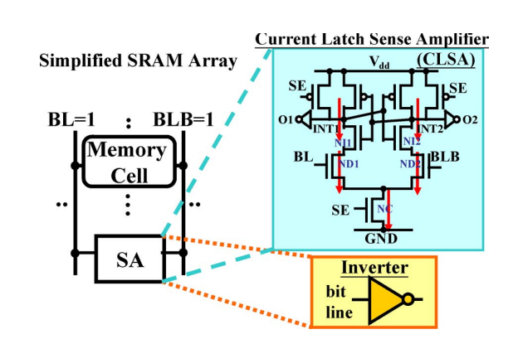

**Current Latch sense amplifier with finfet**

* **Performance Enhancements**
  + Hybrid FinFET-CMOS circuits combine the benefits of both technologies to achieve high speed and energy efficiency (T. Suzuki et al., 2022).
  + Process variations and temperature effects have been mitigated using self-calibrating circuits in FinFET designs (A. Kumar et al., 2020).

Application Survey FinFET are widely used across various high-performance and low-power applications, including:

* **Processors and System-on-Chip (SoC):**
  + Used in advanced CPUs and GPUs for improved performance-per-watt efficiency.
  + Enables high-speed computing in AI accelerators and data centres’.
* **Memory Technologies:**
  + Incorporated in SRAM, DRAM, and emerging non-volatile memory (NVM) for better energy efficiency and reliability.
  + Reduces leakage power in advanced FinFET-based SRAM designs.
* **Mobile and IoT Devices:**
  + Essential for energy-efficient mobile processors in smartphones and wearables.
  + Enables ultra-low-power operation in battery-powered IoT and edge computing devices.
* **Automotive and Aerospace Electronics:**
  + Used in autonomous vehicle processing units and high-reliability aerospace systems.
  + Enhances performance while maintaining low power consumption for mission-critical applications.

**References**

**[1]. A. Chrysanthopoulos, Y. Moisiadis, Y. Tsiatouhas and A. Arapoyanni, “Comparative study of different current mode sense amplifiers in submicron CMOS technology”, IEE Proc.-Circuits Syst., Vol. 149, No. 3, June 2002, pp.154-158.**

**[2]. S. Yang, W. Wang, N. Vijaya Krishnan, and Y. Xie, “Low-leakage robust SRAM cell design for sub-100 nm technologies”, in Proc. ASP- DAC, 2005, pp.539-544**

**[3]. R. Chandrasekaran, Y. Lian, and R. S. Rana, “A high-speed low-power d flip-flop,” in ASIC, 2005. ASICON 2005. 6th International Conference On, vol. 1. IEEE, 2005, pp. 82–85.**